WASH Road Map Visual identity

SUMMARY

NARRATIVES

VISION

TAG LINE

ELEVATOR SPEECH

CONTEXT

VISUAL IDENTITY

LA TYPOGRAPHIE

LES COULEURS

LE LOGOTYPE

TEMPLATES

DOCUMENTS

PPT

BROCHURE

KAKEMONO

SOCIAL MEDIA

TWITTER

LINKED IN

I. Narratives

Motto
Delivering Humanitarian WASH at Scale, Anywhere and Any time

Vision
By 2025, the WASH sector will have the capacity and resources to deliver in emergencies at scale, anywhere and at anytime

Target audience
Primary targets of the Road Map communications are the humanitarian WASH actors, including local actors, the private sectors, donors.
Secondary targets are humanitarian WASH partners including WASH development actors and other humanitarian clusters.

Values
Collaboration, independence, transparency, sustainability

Elevator Speech
A collective of 36 organizations working collaboratively on specific initiatives to improve the quality and scale of emergency Water, Sanitation & Hygiene (WASH) interventions. The initiatives tackle four collectively identified priorities:
- Information and knowledge management
- Capacity development and professionalization
- Coordination and partnerships
- Resource mobilization and advocacy

Context
The humanitarian WASH sector has always been at the core of emergency responses. Ensuring an adequate supply and equitable access to clean water and sanitation services are vital for the affected populations. They are the first steps towards a dignified and preserved life.
However, with the increasing number of affected people, in addition to the increasing length, scale, and complexity of the humanitarian crisis, humanitarian WASH actors recognised they needed to urgently accelerate and adapt their efforts. New approaches had to emerge to save additional lives, to achieve targeted public and environmental health outcomes, and to create synergies between acute emergencies, humanitarian crises, and long-term development.
In October 2019, the Inter-Agencies WASH Group (IAWG) -an informal group of the largest WASH organizations- and the Global WASH Cluster (GWC) invited key WASH stakeholders and agencies to meet and identify challenges and opportunities for the sector. The results were presented to the GWC's annual meeting in 2019 and endorsed by fifteen of the largest organizations involved in the WASH sector. The outcome of this process provides the basis for the strategic framework for the Road Map 2020–2025. It articulates how, through collective commitments and strategic engagement, the humanitarian capacity of the WASH sector ought to be enhanced. The document was then finalized in early 2020, outlining three functional pillars and three operational areas. A year later, in January 2021, the fifteen emergency directors formally approved the Road Map, confirming their commitment to contribute to and support the implementation plan through 16 innovative initiatives, organized in four working groups, each led by one or two of the partner agencies.
Together, they are turning the vision of the WASH Road Map 2025 into a reality: by 2025, the WASH sector will have the capacity and the resources to deliver in emergencies at scale, anywhere, and at any time.

II. Visual identity

TYPOGRAPHY
Use of textual content
The used text must be adapted to the content shared: on images, infographics or other type of visuals, the color of the text must be adapted to come out adequately. On a document, the first primary color as well as black are to be used in priority.
The Verdana font is used in all WASH Road Map communications. ommunications de la Wash RM. Map..
Verdana Titre – 28
Verdana citation intense – 12
Verdana titre 2 - 16
Verdana titre 3 - 13
Verdana en gras - 12
Verdana - 12
COLORS
Light red
RVB :
Hex: #C7004B
Pantone:
Light grey
RVB:
Hex: #E6E6E6
Pantone:
Yellow
RVB:
Hex: #E1A624
Pantone:
Light brown
RVB:
Hex: #AD956B
Pantone:
Sky blue
RVB:
Hex: #4472C4
Pantone:
Dark blue purple
RVB:
Hex: #382254
Pantone:
MAIN COLORS
The following four colors must be used in priority in communications relating to the WRM.

SECONDARY COLORS
The following two colors come in addition to the above four. They may be used to offer additional variations to content (graphs, infographics…).

LOGOTYPE
Use
The logo is part of the visual identity, it alows, through a clear and e logo fait partie intégrante de l’identité visuelle, il permet, à travers un symbole parfois agrémenté d’un texte court, de représenté une entité. Son objectif est purement représentatif : il permet de « signer » ce sur quoi il se trouve en prouvant que l’entité représentée y est présente. Le logo peut également être photo de profil sur les RS.

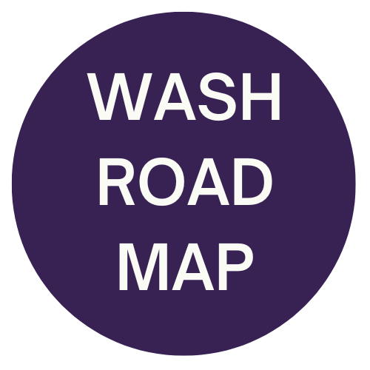

III. Templates

Brochure

// en cours \\

Down below are abstracts of the template documents (Word and Powerpoint) to be used for any WRM communications (minutes, concept notes, financial proposals etc…). They respect colors, fonts and other visual elements tackled above. Their use must be systematic for an effective communication.

DOCUMENTS
- Word Doc et PDF

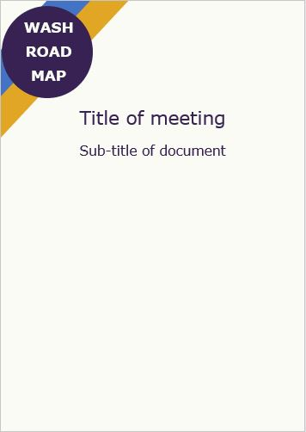
Présence sur les réseaux sociaux

- Bannières
Utilisation
Les banières sont utilisées comme photos de couverture et illustration d’évènements organisés sur les réseaux sociaux. Il intègre normalement le logo, le nom de l’entité et potentiellement la devise de celle-ci. Les couleurs figurées doivent également être celles de la palette de l’identité visuelle.

// à travailler après la validation du logo et des couleurs \\

- Hashtag
Utilisation
Le # est subtil et discret, mais possède un réel pouvoir d’échange, de visibilité et de communication en général. Il ne faut pas sous estimer ce symbole suivi de quelques lettres qui génère souvent un nombre de vus plus élevé et qui permet de répertorier tous les contenus d’une même entité ou d’une même thématique.
- Power Point
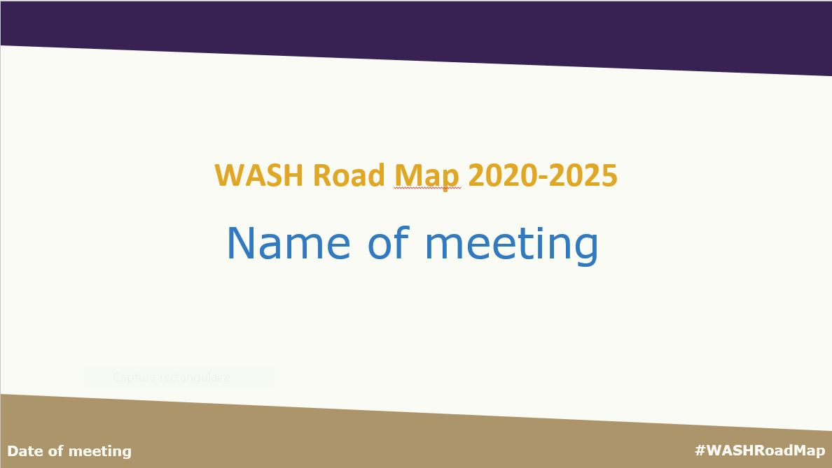
BROCHURE

The briefing paper is available on www.washroadmap.org/public-documentation.html.

KAKEMONO
To be built if needed.
Use
This tool can be used in physical events, to be placed behind speakers and at other strategic places to take pictures in front of for instance, to extend the visibility of the WASH Road Map.
It would be useful to send one to each WRM actor so they can place them in WASH events.

SOCIAL MEDIA

LinkedIn
https://www.linkedin.com/company/wash-road-map/

Twitter
@WASHRoadMap

#ActionForWASH

